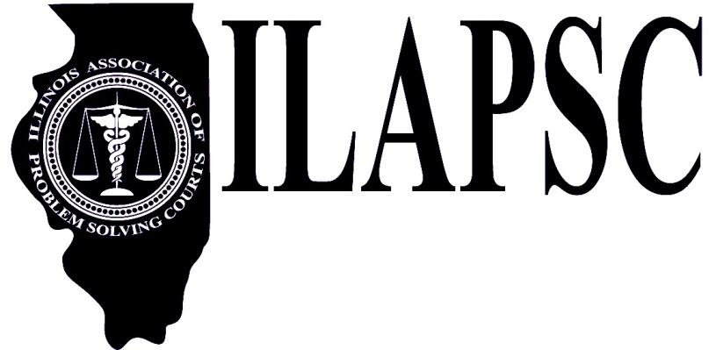 | Illinois Association of Problem-Solving Courts  www.ilapsc.org
ILAPSC Board Meeting
January 23, 2024, 12pm
Via Zoom Teleconference – www.zoom.us
Meeting ID: 779-601-0221 Password ILAPSC

Agenda
- Call to Order and Roll Call
- Minutes from ILAPSC Board Meeting January 23, 2024
- Secretary’s Report
- Treasurer’s Report
- Committee Reports
  - Executive Committee
  - Conference Committee
    - Conference Budget
    - Sponsor & Exhibitor Levels and Benefits
    - Networking Event
    - Awards
  - Public Awareness Committee
  - Board Membership Committee
    - Membership language
- Updates
  - Education/AOIC
  - Legislative/Government
- Old Business
- New Business
- Next Meetings
  - July 23, 2024 – 12:00pm via Zoom
  - September 17, 2024 – 12:00pm via Zoom
  - October 22, 2024, at the Conference
  - November 14-15, 2024, ILAPSC Board Retreat at Starved Rock Lodge

- Adjourn

